FH456-- How to setup WISP mode
Note: This article will guide you how to setup WISP and the steps as below.

Step 1: Connect your computer to the LAN port. Power on the FH456.
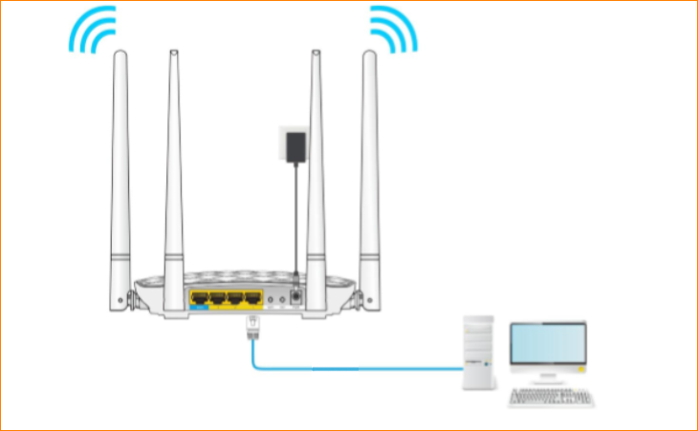
You can also use your smartphone to configure the router.
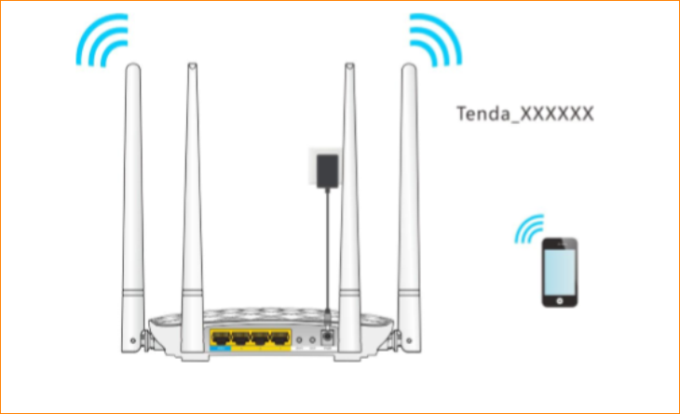
Step 2: Open a Web Browser -> Type http://tendawifi.com or 192.168.0.1 in the address bar -> Press Enter
Step 3: Go to Wireless repeating-> Click “WISP”
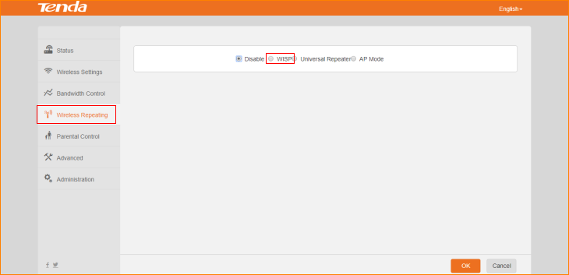
Step4: Select “Upstream WiFi Name”, type password in “WiFi Password”, click “OK” to save all the settings.
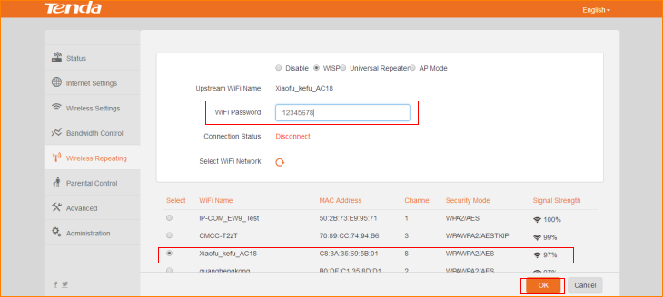
After click “OK”, router reboots automatically. After reboot, connect router’s LAN1/LAN2/LAN3 ports via cable, or reconnect wireless signal of the router, test if you can access the internet. Login the setup page of the router, if the internet settings shows “Connected”! You can access the internet”, means setting successfully. You can check whether you can access the Internet.
